Priority Weightings
The Enterprise Infrastructure Project Prioritization process was developed to weight initiatives according to their impact within three different profiles: Cost, Benefit & Impact.
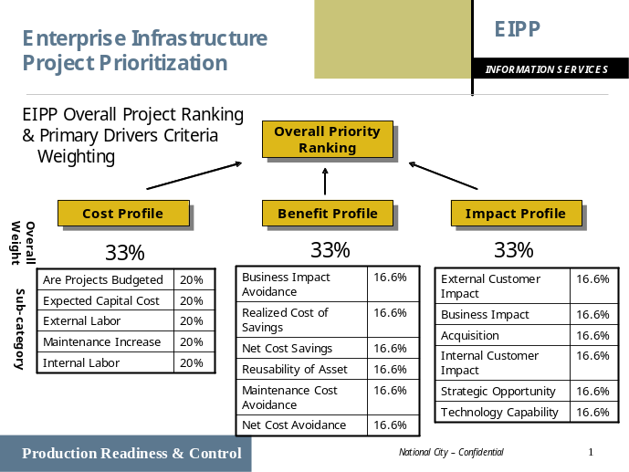The weighting categories and sub-categories requirements were captured in Voice of the Customer and AHP (Weighting) exercises with the major stakeholders within the EPS and Common Services organizations.
As initiatives are entered into the EIPP (Clearview) tool, specific questions are asked to capture the impact, benefit and cost of specific areas. At the conclusion of the initial data capture screen, four total weightings are displayed. Each category (Cost Profile, Benefit Profile & Impact Profile) receive a ranking of 0-100. This weighting will be displayed by a Green, Yellow or Red ranking. The color range for the weightings is currently set as: Green (80-100), Yellow (60-80) and Red (0-60) The overall weighting and sub-category breakdown are found on graph below.
These weightings will be utilized to visibly illustrate the potential impact/benefit within the different infrastructure profiles. These weightings will not determine the individual priority of initiatives, but will be used as an initial guide.
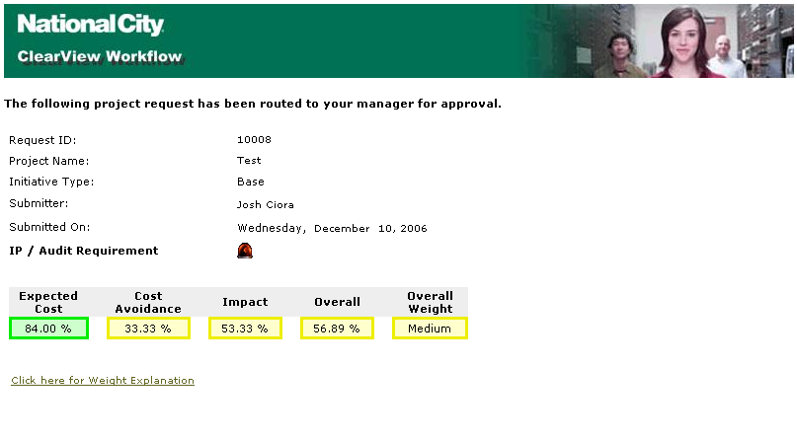
It is recommended that the major stakeholders review the weightings and categories annually to ensure they align with the strategic goals of the organization.

